
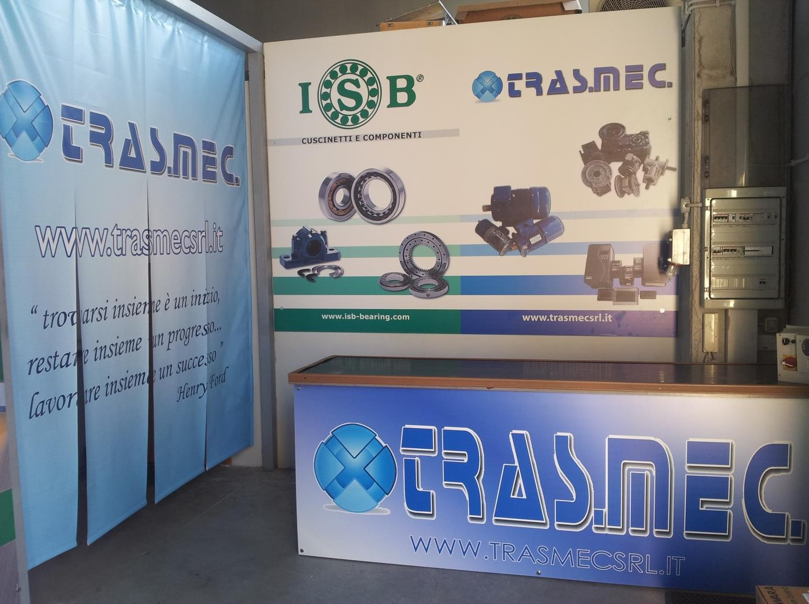

Ecco la vera alternativa ai cuscinetti di marca primaria
Ora qualità, prezzo e servizio a portata di mano…

Cuscinetti scatolati in versione C3 marca ISB

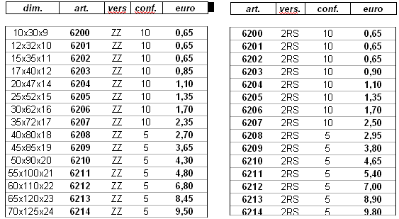
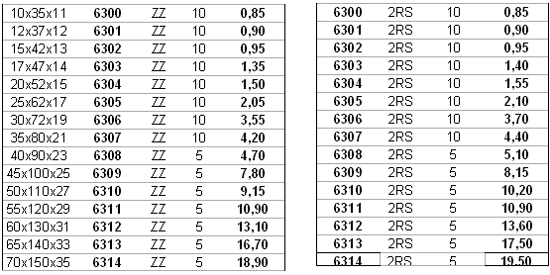

prezzi netti per 100 pezzi totali offerta valida per tutto il 2015

Motori Elettrici IE2

  2 POLI IE2
  TIPO | KW / HP | B3
  80A2-IE2 | 0,75/1 | €72,50
  80B2-IE2 | 1,1/1,5 | €80,25
  90S2-IE2 | 1,5/2 | €105,45
  90L2-IE2 | 2,2/3 | €113,50
  100L2-IE2 | 3,0/4 | €156,00
  112M2-IE2 | 4/5,5 | €189,50
  132SA2-IE2 | 5,5/7,5 | €272,50
  132SB2-IE2 | 7,5/10 | €309,00
  160MA2-IE2 | 11/15 | €488,00
  160MB2-IE2 | 15/20 | €545,00
  160L2-IE2 | 18,5/25 | €597,50
  180M2-IE2 | 22/30 | €770,00
  200LA-IE2 | 30/40 | €1.026,00
  200LB2-IE2 | 37/50 | €1.110,00
  225M2-IE2 | 45/60 | €1.285,00
  250M2-IE2 | 55/75 | €1.790,00
  280S2-IE2 | 75/100 | €2.280,00
  280M2-IE2 | 90/125 | €2.612,50
  315S2-IE2 | 110/150 | €4.145,00
  315M2-IE2 | 132/180 | €4.370,00
  315LA2-IE2 | 160/220 | €4.528,00
  315LB2-IE2 | 200/270 | €4.636,50
  355M2-IE2 | 250/340 | €7.577,00
  355L2-IE2 | 315/430 | €8.319,50
  4 POLI IE2
  TIPO | KW / HP | B3
  80B4-IE2 | 0,75/1 | €76,00
  90S4-IE2 | 1,1/1,5 | €99,00
  90L4-IE2 | 1,5/2 | €110,00
  100LA4-IE2 | 2,2/3 | €143,00
  100LB4-IE2 | 3,0/4 | €161,50
  112M4-IE2 | 4/5,5 | €209,00
  132S4-IE2 | 5,5/7,5 | €280,00
  132M4-IE2 | 7,5/10 | €319,00
  160M4-IE2 | 11/15 | €488,00
  160L4-IE2 | 15/20 | €579,50
  180M4-IE2 | 18,5/25 | €724,00
  180L4-IE2 | 22/30 | €760,00
  200L4-IE2 | 30/40 | €1.026,00
  225S4-IE2 | 37/50 | €1.242,00
  225M4-IE2 | 45/60 | €1.392,50
  250M4-IE2 | 55/75 | €1.723,50
  280S4-IE2 | 75/100 | €2.230,00
  280M4-IE2 | 90/125 | €2.493,00
  315S4-IE2 | 110/150 | €3.765,00
  315M4-IE2 | 132/180 | €4.212,50
  315LA4-IE2 | 160/220 | €4.813,00
  315LB4-IE2 | 200/270 | €5.404.00
  355M4-IE2 | 250/340 | €7.461,50
  355L4-IE2 | 315/430 | €8.600,00
 | 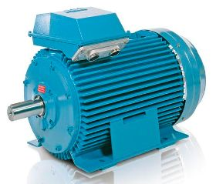  Es:Flangiato B3
  6 POLI IE2
  TIPO | KW / HP | B3
  90S6-IE2 | 0,75/1 | €108,50
  90L6-IE2 | 1,1/1,5 | €131,50
  100L6-IE2 | 1,5/2 | €164,00
  112MA6-IE2 | 2,2/3 | €217,50
  132S6-IE2 | 3,0/4 | €274,00
  132MA6-IE2 | 4/5,5 | €298,50
  132MB6-IE2 | 5,5/7,5 | €337,50
  160M6-IE2 | 7,5/10 | €445,00
  160L6-IE2 | 11/15 | €565,00
  180L6-IE2 | 15/20 | €709,50
  200LA6-IE2 | 18,5/25 | €885,50
  200LB6-IE2 | 22/30 | €942,50
  225M6-IE2 | 30/40 | €1.385,00
  250M6-IE2 | 37/50 | €1.683.50
  280S6-IE2 | 45/60 | €2.155,00
  280M6-IE2 | 55/75 | €2.223,00
  315S6-IE2 | 75/100 | €3.930,00
  315M6-IE2 | 90/125 | €4.120,00
  315LA6-IE2 | 110/150 | €4.736,50
  315LB6-IE2 | 132/180 | €5.221,50
  355MA6-IE2 | 160/220 | €6.469,50
  355MB6-IE2 | 200/270 | €6.940,50
  355LB6-IE2 | 250/340 | €7.981,00
  355LC6-IE2 | 315/430 | €10.370,00

Per versione B5 o B3-B5 il prezzo è maggiorato del 5%

Motori Elettrici IE3

-IEC60034-30:IE3 EFFICIENZA PREMIUM -REGOLAMENTO CE N.640/2009
-DAL 01/01/2015 OBBLIGO IE3 PER TUTTI I MOTORI TRIFASE 2/4/6 POLI DA 7,5 AL 375 KW (DAL 01/01/2017 L’OBBLIGO SI ESTENDE ANCHE AI MOTORI DA 0,75 AL 7,5 KW)

  2 POLI IE3
  TIPO | KW / HP | B3
  80A2-IE3 | 0,75/1 | €72,50
  80B2-IE3 | 1,1/1,5 | €80,65
  90S2-IE3 | 1,5/2 | €105,50
  90L2-IE3 | 2,2/3 | €113,90
  100L2-IE3 | 3,0/4 | €162,50
  112M2-IE3 | 4/5,5 | €195,50
  132SA2-IE3 | 5,5/7,5 | €272,75
  132SB2-IE3 | 7,5/10 | €309,00
  160MA2-IE3 | 11/15 | €551,00
  160MB2-IE3 | 15/20 | €611,00
  160L2-IE3 | 18,5/25 | €659,00
  180M2-IE3 | 22/30 | €918,50
  200LA-IE3 | 30/40 | €1.032,00
  200LB2-IE3 | 37/50 | €1.115,00
  225M2-IE3 | 45/60 | €1.367,50
  250M2-IE3 | 55/75 | €1.790,00
  280S2-IE3 | 75/100 | €2.369,00
  280M2-IE3 | 90/125 | €2.612,50
  315S2-IE3 | 110/150 | €4.145,00
  315M2-IE3 | 132/180 | €4.370,00
  315LA2-IE3 | 160/220 | €4.528,00
  315LB2-IE3 | 200/270 | €5.387,00
  355M2-IE3 | 250/340 | €7.773,00
  355L2-IE3 | 315/430 | €8.493,00
  4 POLI IE3
  TIPO | KW / HP | B3
  80B4-IE3 | 0,75/1 | €91,90
  90S4-IE3 | 1,1/1,5 | €111,45
  90L4-IE3 | 1,5/2 | €124,09
  100LA4-IE3 | 2,2/3 | €170,64
  100LB4-IE3 | 3,0/4 | €194,01
  112M4-IE3 | 4/5,5 | €216,05
  132S4-IE3 | 5,5/7,5 | €280,00
  132M4-IE3 | 7,5/10 | €322,10
  160M4-IE3 | 11/15 | €551,50
  160L4-IE3 | 15/20 | €630,50
  180M4-IE3 | 18,5/25 | €812,50
  180L4-IE3 | 22/30 | €948,50
  200L4-IE3 | 30/40 | €1.223,00
  225S4-IE3 | 37/50 | €1.365,15
  225M4-IE3 | 45/60 | €1.456,00
  250M4-IE3 | 55/75 | €1.944,50
  280S4-IE3 | 75/100 | €2.522,00
  280M4-IE3 | 90/125 | €2.930,50
  315S4-IE3 | 110/150 | €4.421,50
  315M4-IE3 | 132/180 | €4.749,00
  315LA4-IE3 | 160/220 | €5.087,50
  315LB4-IE3 | 200/270 | €6.328.00
  355M4-IE3 | 250/340 | €8.173,00
  355L4-IE3 | 315/430 | €8.626,00
 | 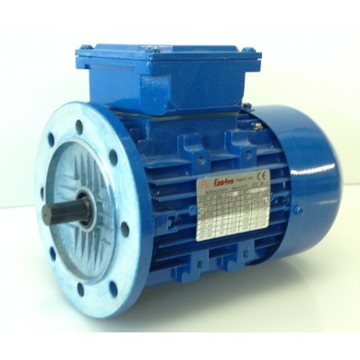  Es:Flangiato B5
  6 POLI IE3
  TIPO | KW / HP | B3
  90S6-IE3 | 0,75/1 | €110,25
  90L6-IE3 | 1,1/1,5 | €131,50
  100L6-IE3 | 1,5/2 | €164,00
  112MA6-IE3 | 2,2/3 | €217,50
  132S6-IE3 | 3,0/4 | €274,00
  132MA6-IE3 | 4/5,5 | €300,95
  132MB6-IE3 | 5,5/7,5 | €346,45
  160M6-IE3 | 7,5/10 | €516,50
  160L6-IE3 | 11/15 | €602,00
  180L6-IE3 | 15/20 | €804,50
  200LA6-IE3 | 18,5/25 | €961,50
  200LB6-IE3 | 22/30 | €1033,00
  225M6-IE3 | 30/40 | €1.385,00
  250M6-IE3 | 37/50 | €1.683.50
  280S6-IE3 | 45/60 | €2.155,00
  280M6-IE3 | 55/75 | €2.301,50
  315S6-IE3 | 75/100 | €3.930,00
  315M6-IE3 | 90/125 | €4.120,00
  315LA6-IE3 | 110/150 | €4.736,50
  315LB6-IE3 | 132/180 | €5.221,50
  355MA6-IE3 | 160/220 | €7.462,50
  355MB6-IE3 | 200/270 | €8.008,00
  355LB6-IE3 | 250/340 | €9.340,00

Per versione B5 o B3-B5 il prezzo è maggiorato del 5%

Inverter TOSHIBA

Serie VF-S15 230V trifase senza STO

Modello | Specifiche ( carico gravoso) | Prezzo
VF.S15 2004 PM-W | Motore 0.4 KW – In 3.3A a 50° | €172,25
VF.S15 2007 PM-W | Motore 0.75 KW – In 4.8A a 50° | €159,50
VF.S15 2015 PM-W | Motore 1.5 KW – In 8A a 50° | €206,25
VF.S15 2022 PM-W | Motore 2.2 KW – In 11A a 50° | €240,65
VF.S15 2037 PM-W | Motore 4.0 KW – In 17.5A a 50° | €341,00
VF.S15 2055 PM-W | Motore 5.5 KW – In 27.5A a 50° | €544,50
VF.S15 2075 PM-W | Motore 7.5 KW – In 33A a 50° | €577,50
VF.S15 2110 PM-W | Motore 11 KW – In 54A a 50° | €715,00
VF.S15 2150 PM-W | Motore 15 KW – In 66A a 50° | €1.017,50

Serie VF-S15 400V trifase senza STO

Modello | Specifiche ( carico gravoso) | Prezzo
VF-S15 4004 PL-W | Motore 0.4 KW – In 1.5A a 50° | €167,75
VF-S15 4007 PL-W | Motore 0.75 KW – In 2.3A a 50° | €178,75
VF-S15 4015 PL-W | Motore 1.5 KW – In 4.1A a 50° | €220,00
VF-S15 4022 PL-W | Motore 2.2 KW – In 5.5A a 50° | €255,75
VF-S15 4037 PL-W | Motore 4 KW – In 9.5A a 50° | €308,00
VF-S15 4055 PL-W | Motore 5.5 KW – In 14.3A a 50° | €437,25
VF-S15 4075 PL-W | Motore 7.5 KW – In 17A a 50° | €475,75
VF-S15 4110 PL-W | Motore 11 KW – In 27.7A a 50° | €618,75
VF-S15 4150 PL-W | Motore 15 KW – In 33A a 50° | €822,25

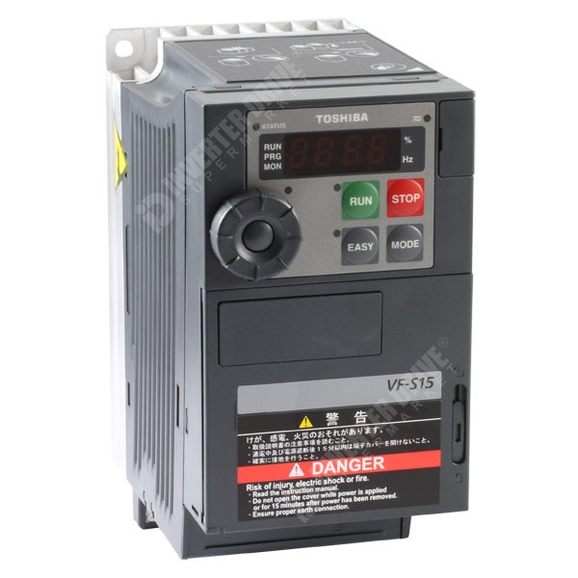

Serie VF-PS1 400V trifase

Modello | Specifiche ( carico gravoso) | Prezzo
VF-PS1 4185 PL-WN | Motore 18.5 KW – In 41.0A a 50° | €1.072,50
VF-PS1 4220 PL-WN | Motore 22 KW – In 48A a 50° | €1.369,50
VF-PS1 4300 PL-WN | Motore 30 KW – In 66A a 50° | €1.727,00
VF-PS1 4370 PL-WN | Motore 37 KW – In 79A a 50° | €1.925,00
VF-PS1 4450 PL-WN | Motore 45 KW – In 94A a 50° | €2.431,00
VF-PS1 4550 PL-WN | Motore 55 KW – In 116A a 50° | €2.887,50
VF-PS1 4750 PL-WN | Motore 75 KW – In 160A a 50° | €3.630,00
VF-PS1 4900 PC-WN | Motore 90 KW – In 179A a 50° | €4.565,00
VF-PS1 4110 KPC-WN | Motore 110 KW – In 215A a 50° | €4.895,00
VF-PS1 4132 KPC-WN | Motore 132 KW – In 259A a 50° | €5.610,00
VF-PS1 4160 KPC-WN | Motore 160 KW – In 314A a 50° | €7.590,00
VF-PS1 4220 KPC-WN | Motore 220 KW – In 427A a 50° | €10.450,00
VF-PS1 4250 KPC-WN | Motore 250 KW – In 481A a 50° | €10.862,50
VF-PS1 4280 KPC-WN | Motore 280.0 KW – In 550A a 50° | €11.770,00
VF-PS1 4315 KPC-WN | Motore 315.0 KW – In 616A a 50° | €12.677,00
VF-PS1 4400 KPC-WN | Motore 400.0 KW – In 759A a 50° | €19.937,00
VF-PS1 4500 KPC-WN | Motore 500.0 KW – In 941A a 50° | €27.500,00
VF-PS1 4630 KPC-WN | Motore 630.0 KW – In 1118.A a 50° | €31.350,00

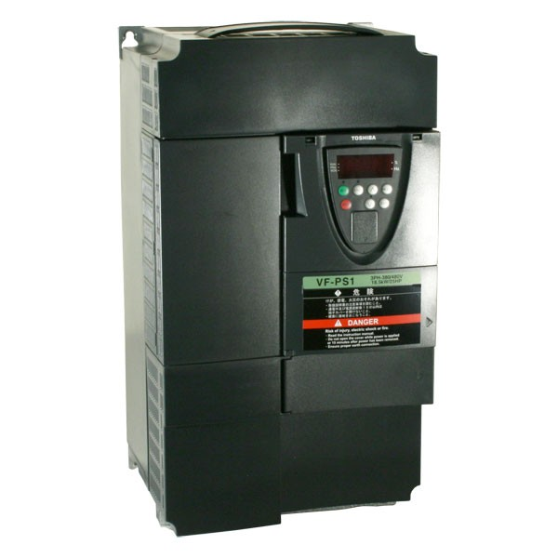

Serie VF-NC3S 230V monofase

Modello | Specifiche ( carico gravoso) | Prezzo
VF-NC3S 2002PL-W | Motore 0.25KW – In 1.4A a 50° | €86,65
VF-NC3S 2004PL-W | Motore 0.4KW – In 2.4A a 50° | €89,50
VF-NC3S 2007PL-W | Motore 0.75KW – In 4.2A a 50° | €96,25
VF-NC3S 2015PL-W | Motore 1.5KW – In 7.5A a 50° | €154,00
VF-NC3S 2022PL-W | Motore 2.2KW – In 10A a 50° | €192,50

