
SKF Certified Rebuilder: Electric Motors

Performance advantages

- Lower total cost of ownership through:
––Increased productivity ––Decreased downtime ––Lower maintenance costs ––Reduced energy consumption

- Extended Mean Time Between Failure

- Enhanced reliability

- Quality SKF components

Stop the cycle of motor repair: Use an SKF Certified Rebuilder
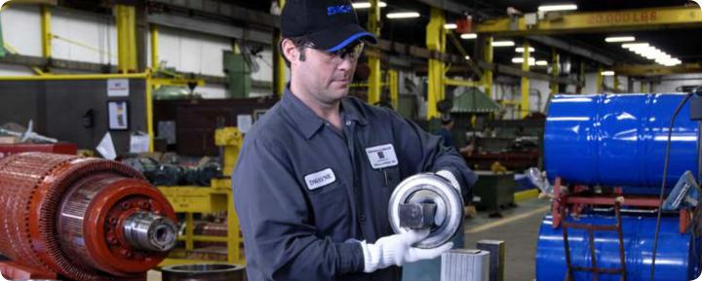

SKF certification advantages

- Conformance to exacting SKF specifications and standards

- Reliable, high-quality rebuilds

- Root cause failure analysis

- Ongoing training

- Access to SKF technology

- SKF bearings – always

- Auditing and re-certification mandatory

It’s no secret that electric motor reliability can be a problem. The fact is that electric motors are among the highest in reliability incident reports, a problem that leads to a continual cycle of costly repairs and unplanned downtime. While bearing failure is recognized as the primary mechanical symptom of motor failure, most motor repair shops are not trained to investigate the underlying causes of bearing failure such as improper maintenance, handling, installation and service. In most cases, motor repair shops simply replace the bearings and return the motor, which once again, is doomed for failure. And the cycle continues.

Move from continual repair to constant reliability
You can stop the cycle of continual repair costs and downtime by demanding that an SKF Certified Rebuilder repairs your electric motors. Their personnel under-goes specialized training in motor repair

with an emphasis on root cause failure analysis, bearing installation, lubrication, and condition monitoring. The objective: prevent reoccurring failures and extend motor service life. SKF Certified Rebuild-ers must meet exacting standards and specifications, and are regularly audited to make sure they comply. Repairs are done right, every time, using only SKF bearings.

Start expecting more: Enhance productivity and profitability

By identifying and eliminating the root causes of bearing failure, rebuilds carried out by an SKF Certified Rebuilder opens the door to new levels of motor reliability and productivity, strengthening your bottom line. In addition, your motors can operate at peak efficiency, which can have a significant impact on energy consumption.


Using an SKF Certified Rebuilder: The smart way to service motors. The sure way to enhance reliability.

SKF Certified: The new stand-ard of service excellence
As a collaborative effort between SKF, eligible motor service firms, and partici-pating SKF Authorized Distributors, the SKF Certified electric motor rebuilder programme raises the bar on motor service.

Industry statistics have shown that between 40% and 70% of electric motor failures are bearing related. For this reason, the SKF Certified programme focuses on identifying the root cause of bearing failure and the

repair methods that correct the problem so that the motor can achieve optimum performance.

Certification requires that personnel undergo extensive training in identifying and evaluating the factors that influence bearing service life. Technicians are tested and required to meet certification requirements. SKF Certified Rebuilders are regularly audited to make sure they comply with program standards.

Here’s what you can expect from an SKF Certified Rebuilder
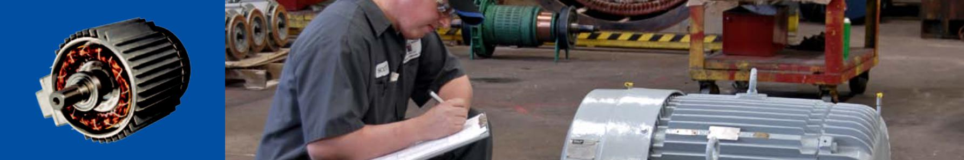
SKF trained, highly skilled service professionals that are equipped with the latest tools and equipment to make sure that your motor is serviced right every time.

Consistent specifications and standards

SKF has established specification standards that must be met for every motor repair. By using an SKF Certified Rebuilder, you can be sure that each rebuilt motor meets the highest stand-ards for quality and consistency. In addition to regular audits to confirm that motors are rebuilt according to specifica-tion, each shop is audited for cleanliness, orderliness and environmental responsi-bility.

Root cause failure analysis

Most repair shops don’t do such analysis. An SKF Certified Rebuilder is required and trained to do it. Your motor is thoroughly analyzed to determine the cause of failure. After a complete check of those components that could have a negative impact on bearing and motor service life, necessary repairs are made so that your motor can run at optimum efficiency. The benefits are clear: a longer
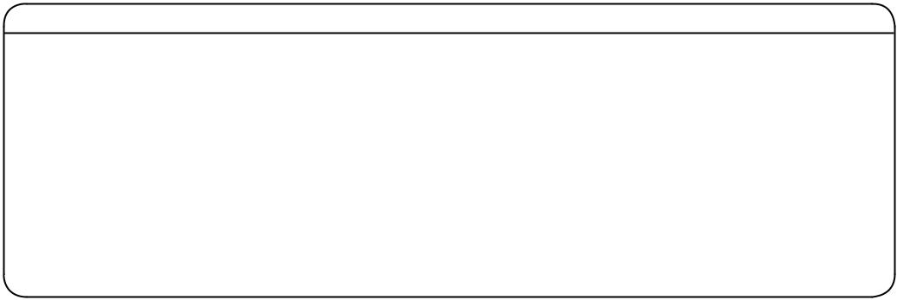

lasting motor that will run smoother and cooler and reduce energy consumption.

Advanced technology and equipment

SKF Certified Rebuilders have access to SKF’s leading bearing technology and engineering expertise. And certification requires that repair shops utilize the best available equipment for bearing dis-mounting, measurement, repair and mounting.

Quality SKF products and practices

When your motor is serviced by an SKF Certified Rebuilder, only SKF bearings will be used. And, repairs will be per-formed in an environment that meets SKF’s stringent requirements for cleanliness, and proper storage and handling of bearings, components and serviced motors.

Ongoing excellence

As new products, tools and repair methods are developed, SKF Certified Rebuilder procedures will be updated, and on-going training and certification are mandatory. That means you will always have the advantage of SKF’s ongoing commitment to excellence.

Trust the SKF certification advantage
Stop the cycle of motor repair. Require that your electric motor repair shop be SKF Certified, and move to a higher level

For more information, contact your SKF Certified Rebuilder
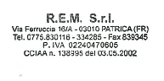
of reliability, productivity – and enhanced profit potential.

® SKF is a registered trademark of the SKF Group.

© SKF Group 2009

The contents of this publication are the copyright of the publisher and may not be reproduced (even extracts) unless prior written per-mission is granted. Every care has been taken to ensure the accuracy of the information contained in this publication but no liability can be accepted for any loss or damage whether direct, indirect or consequential arising out of the use of the information contained herein.
PUB BU/S9 06889/1 EN · November 2009

skf.com

