Buongiorno,

di seguito il link per accedere al sistema demo Schaeffler Optime

[Mattia @ cm20prod.westeurope.cloudapp.azure.com](https://cm20prod.westeurope.cloudapp.azure.com/Dashboard/)

Username: Buzzi demo

Password: Buzzi_guidonia22

Carlo Spaziani e noi restiamo a disposizione per maggiori approfondimenti in merito.

Ci risentiamo tra un paio di settimane/un mese per commentare insieme i dati acquisiti dal sistema pilota.

Cordiali saluti,

Mattia Tonati

Sales Manager Industry 4.0



Schaeffler Italia S.r.l.  
Via Dr. Georg Schaeffler, 7  
28015 Momo (NO) Italia

Tel. +39 0321 929 309 · mobile. +39 342 68 85 154  
[mattia.tonati@schaeffler.com](mailto:mattia.tonati@schaeffler.com) · [http://www.schaeffler.com](http://www.schaeffler.com/) · [http://www.schaeffler.it](http://www.schaeffler.it/)

[](https://www.facebook.com/SchaefflerDeutschland)   [](https://twitter.com/schaefflerpress)   [](https://www.instagram.com/schaefflergroup/)   [](https://www.youtube.com/user/SchaefflerDE)   [](http://www.linkedin.com/company/schaeffler)   [](https://www.xing.com/company/schaeffler)

_________________________________  
This e-mail message is intended only for the use of the named recipient(s) and contains information which may be confidential or privileged. If you are not the intended recipient, be aware that any distribution, or use of the contents of this information is prohibited. If you have received this electronic transmission in error, please notify the sender and delete the material from the computer.

[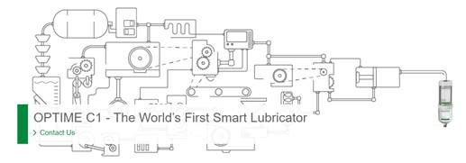](https://medias.schaeffler.it/it/lubrication/lubricators/optime-c1#optimec1-contact)