NUOVA PIATTAFORMA OPTIME:

http://remmotori.schaeffler-optime.io/web/ui#/g6w2hgudy8/summary
login Angelo
subscription: remmotori
username: officina@rem-motori.it
Password: An21091966@
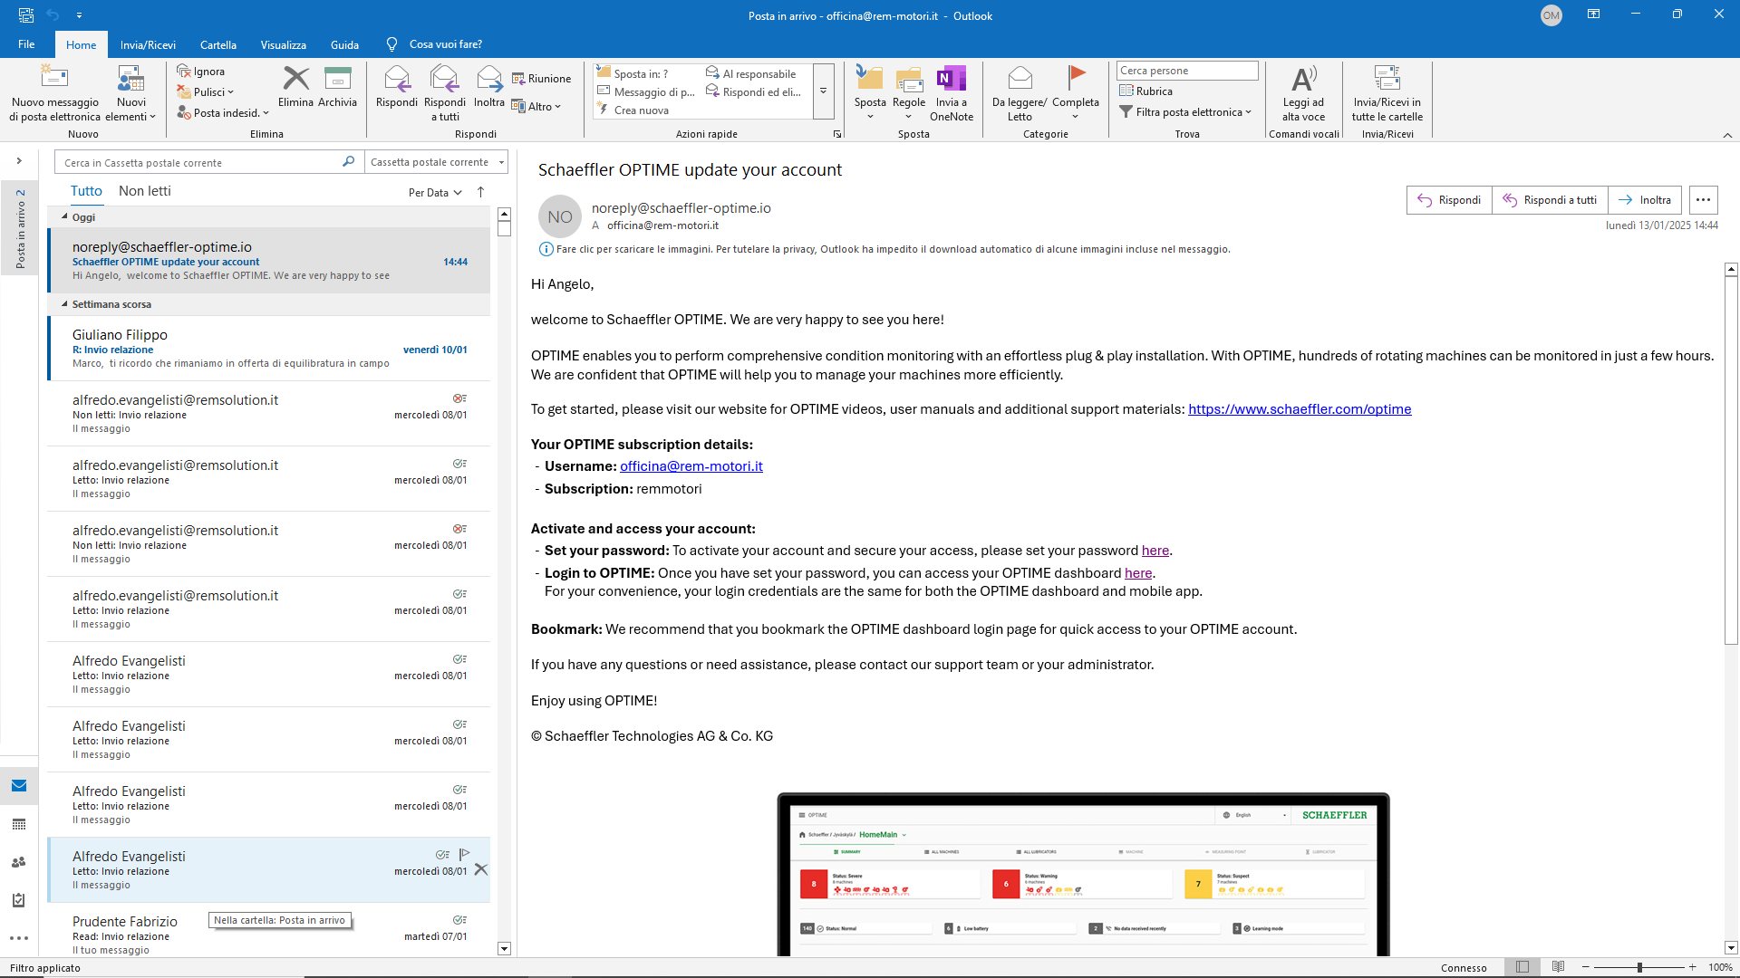

Login Costantino
Username: info@remsolution.it
Subscription: remmotori
Password: Costa86@
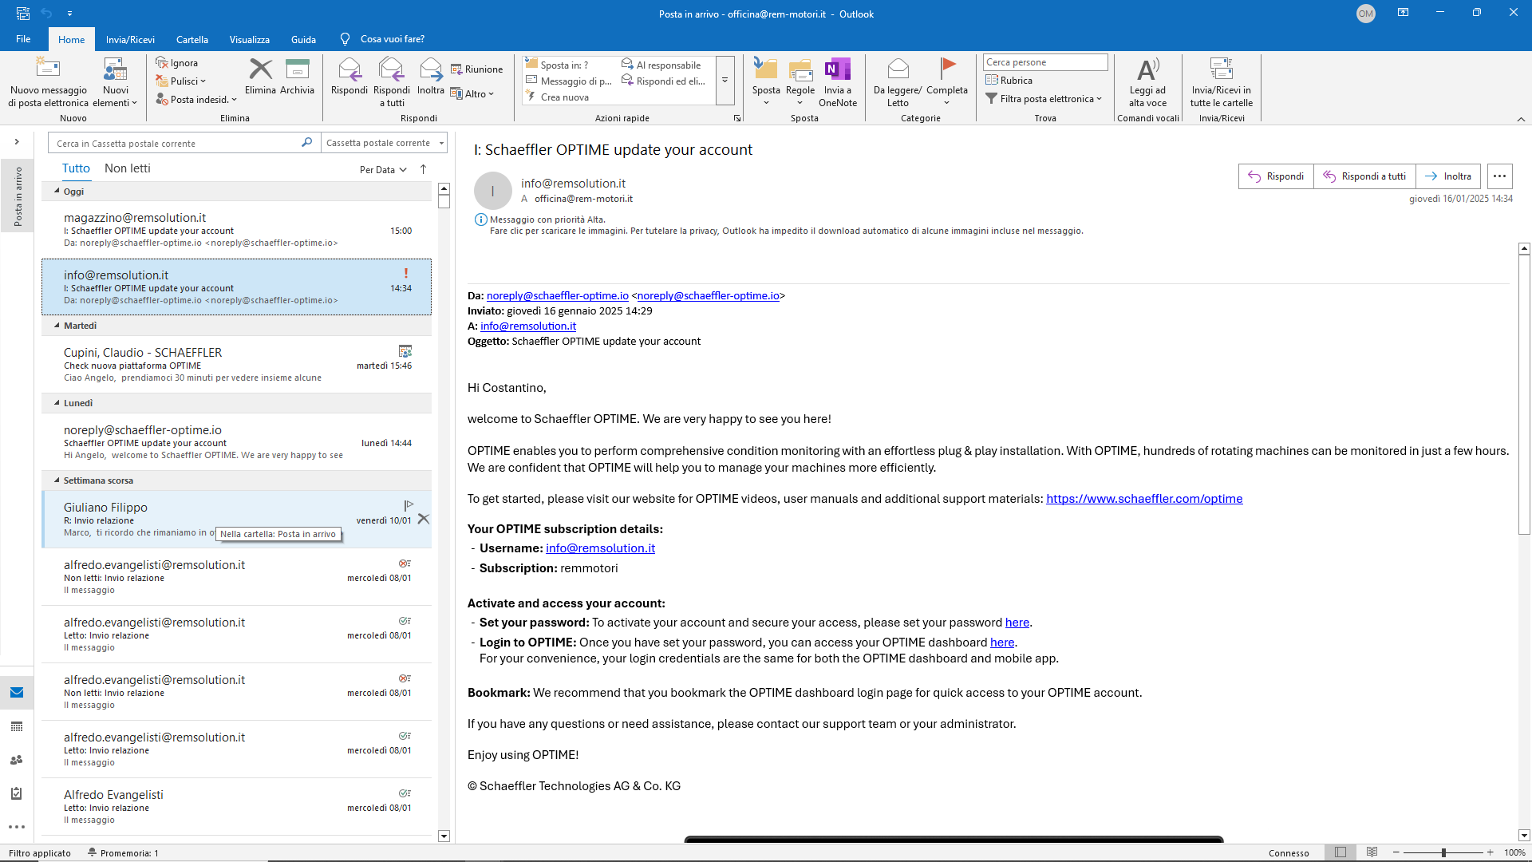

Login Jacopo
Username: magazzino@remsolution.it
Subscription: remmotori
Password: Jacop93@

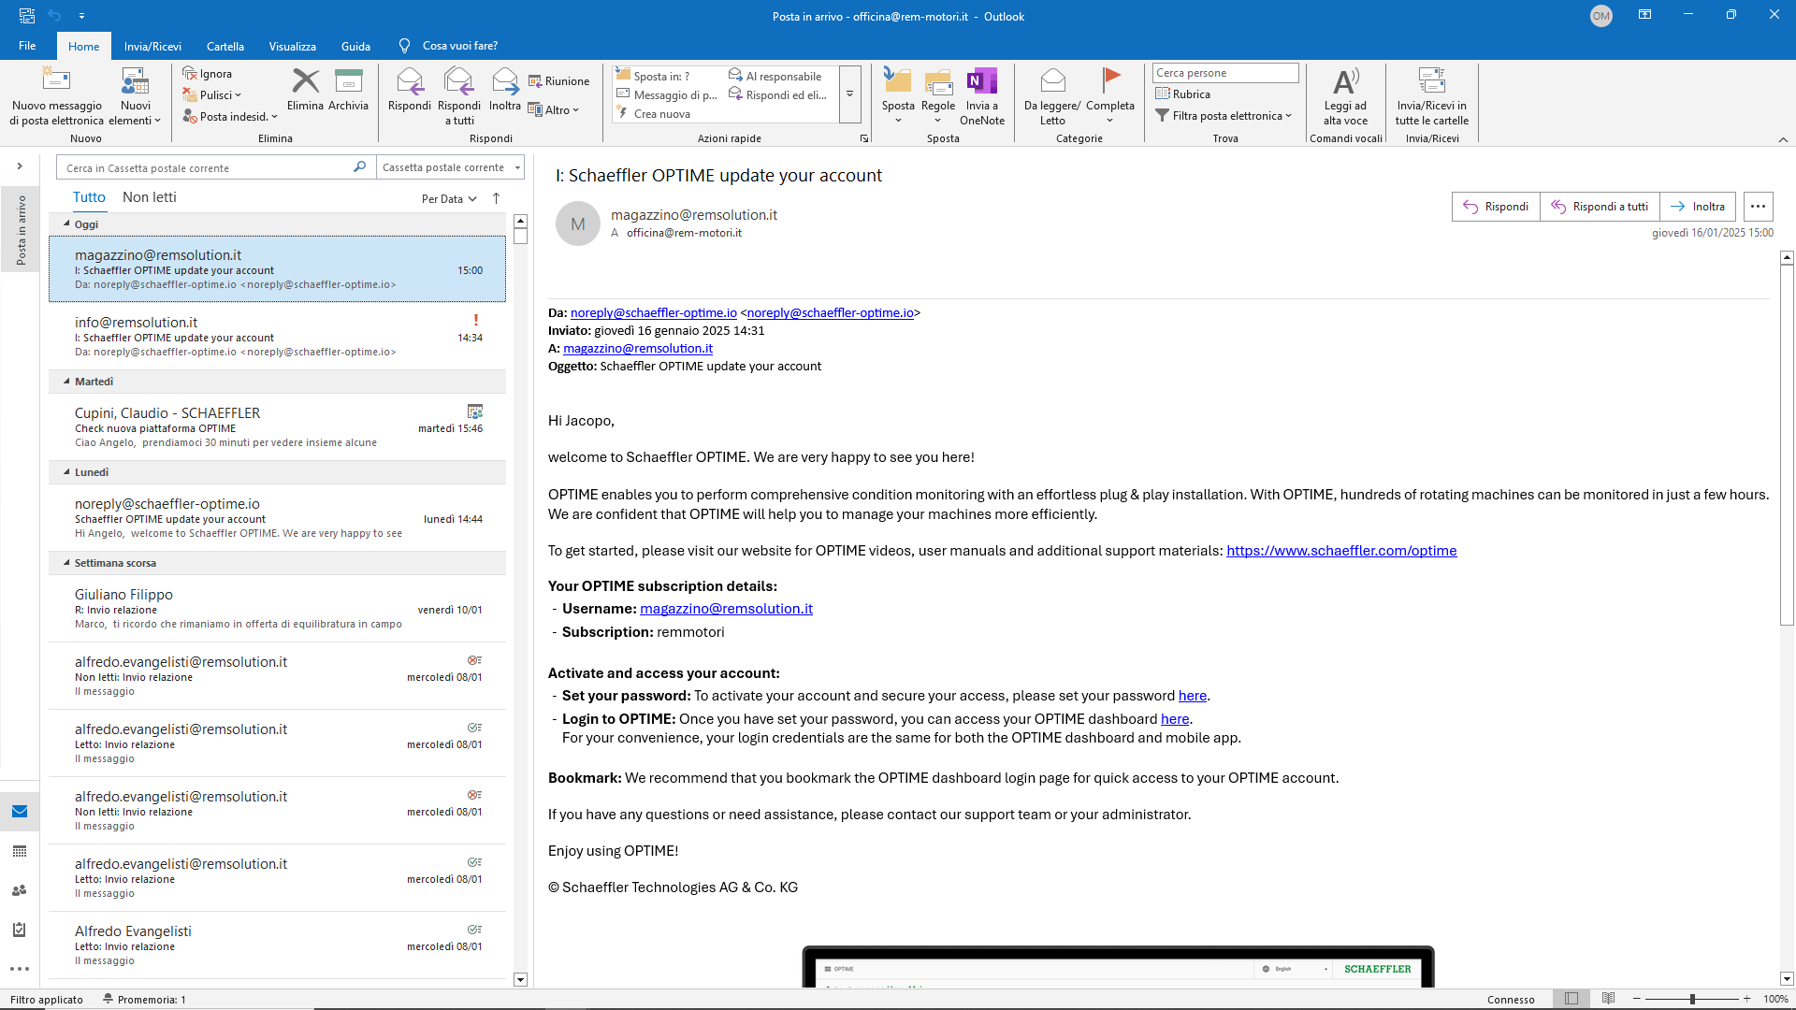

http://remmotori.schaeffler-optime.io/web/ui#/g6w2hgudy8/summary
ACCOUNT OPTIME
Login Jacopo
Username: magazzino@remsolution.it
Subscription: remmotori
Password: Jacop93@

http://remmotori.schaeffler-optime.io/web/ui#/g6w2hgudy8/summary
Login Costantino
Username: info@remsolution.it
Subscription: remmotori
Password: Costa86@

http://remmotori.schaeffler-optime.io/web/ui#/g6w2hgudy8/summary
Login Angelo
subscription: remmotori
username: officina@rem-motori.it
Password: An21091966@

http://remmotori.schaeffler-optime.io/web/ui#/g6w2hgudy8/summary
Login Alfredo
Username: alfredo.evangelisti@rem-motori.it
Subscription: remmotori
Password: Ale1967@

