R.E.S. Tecnology S.r.l.
Str. Vlaicu Pĭrcălab, 33-ap.7 Chisinau (MD)

Subject: Reference number offer 003/2017 and Order of realization of Electric Schemes 2016_0492

We send this letter to accept your offer number 003/2017. The bid amount is accepted for € 2.150,00 + VAT with a discount of 5%.
Delivery time: 4/5 weeks from order except unexpected.
Transport: included.
Payment: to be agreed upon.
We are available for any clarification, we wish you good work and we send you
Best regards.
R.E.M. Srl

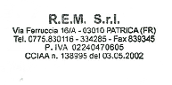 Italy, Patrica, 06/06/2017

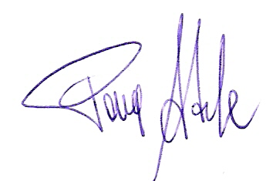
Firma del Rapp. Legale
Adele Pace

