Spett.le LEROY SOMER
Zone Industrielle des AGRIERS
Impasse LEROY
16000 ANGOULEME

DELEGATION OF FUNCTIONS

The undersigned Adele Peace, born on 25/01/1960 in Ferentino prov. FR (Italy) and resident in Via Aldo Moro n° 245 prov. FR (Italy) Street CAP 03100 tax code PCADLA60A65D539K AS5857727 identity document issued by the municipality of FROSINONE on 18/05/2011 and valid, as legal representative of R.E.M. Srl VAT 02240470605
I bequeath

the company Ge.Co Srl, with its driver, based in Fiuggi via S.S. 155 number 12, 03011 Alatri (FR-Italy), VAT 02583800608, to collect the material for my account. Our order number is 2017/0359 of 27/07/2017.

Patrica, 01/08/2017
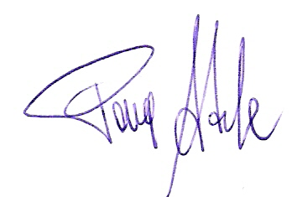

Firma del Rapp. Legale
Adele Pace

