Buonasera

in allegato l’offerta ,

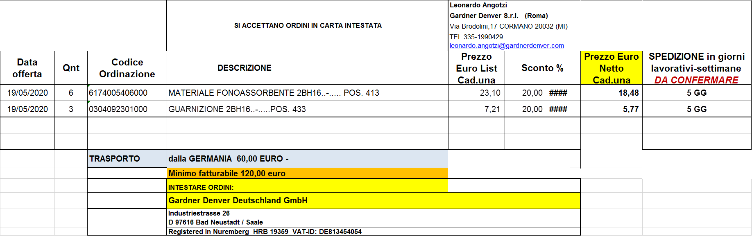

Cordiali saluti,

**Leonardo Angotzi**

**Sales |Industrials Group**

UMBRIA-LAZIO-CAMPANIA-MOLISE

PUGLIA-BASILICATA-CALABRIA-SICILIA

**Gardner Denver S.r.l. - Roma**

Via Giacomo Brodolini, 17

20032 Cormano (MI) – IT

E-mail: [leonardo.angotzi@gardnerdenver.com](mailto:leonardo.angotzi@gardnerdenver.com)

Cell. 335-1990429

[www.irco.com](http://www.irco.com/)

[www.gardnerdenver.com/elmorietschle](http://www.gardnerdenver.com/elmorietschle)

cid:image001.png@01D627B6.FCAC26C0