**GRANDE MAROCCO**

**S/G SYNCHRONOUS CONDENSER GENERATOR HEAVY VIBRATION**

Due to Heavy Vibration(without unusual sound) S/G shot down and perform investigation, first we check the coupling alignment and found around 0.4mm deviation, Maximum allowed is 0.15mm.

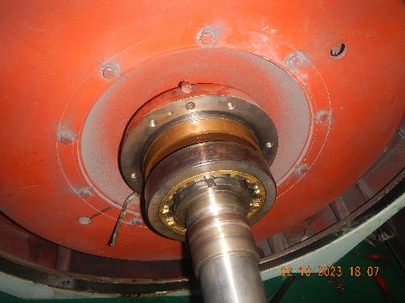 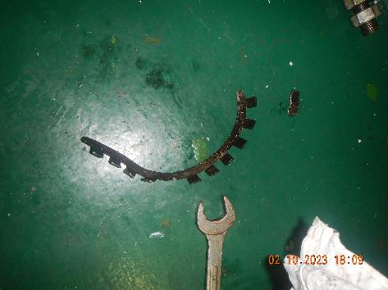

Unit was dismantled for inspection and found the locking ring damage, due to the rotation of the bearing bush on the Rotor shaft

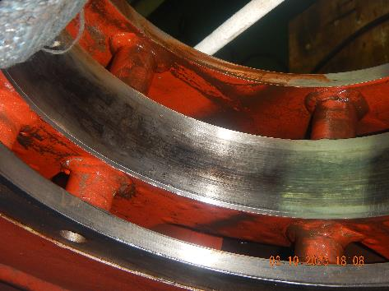 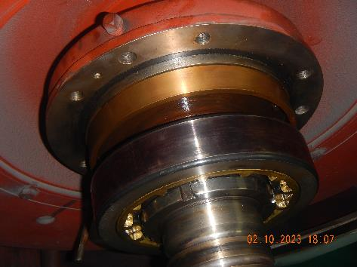

Dark/burned marks on the bearing housing and outer bearing also due to its rotation.

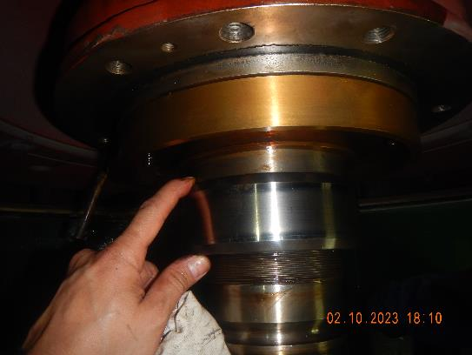 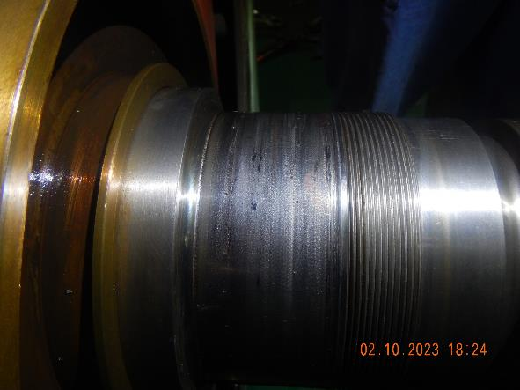

Bearing bush was loose on the shaft, dismantled and found the rotor shaft worn out(burnt marks), Using vernier caliper, Shafting were the bearing bush is situated were reduced from 120mm to 119. 4mm, around 0.6mm were consumed and these is the reason of the large coupling deviation and heavy vibration of the unit.