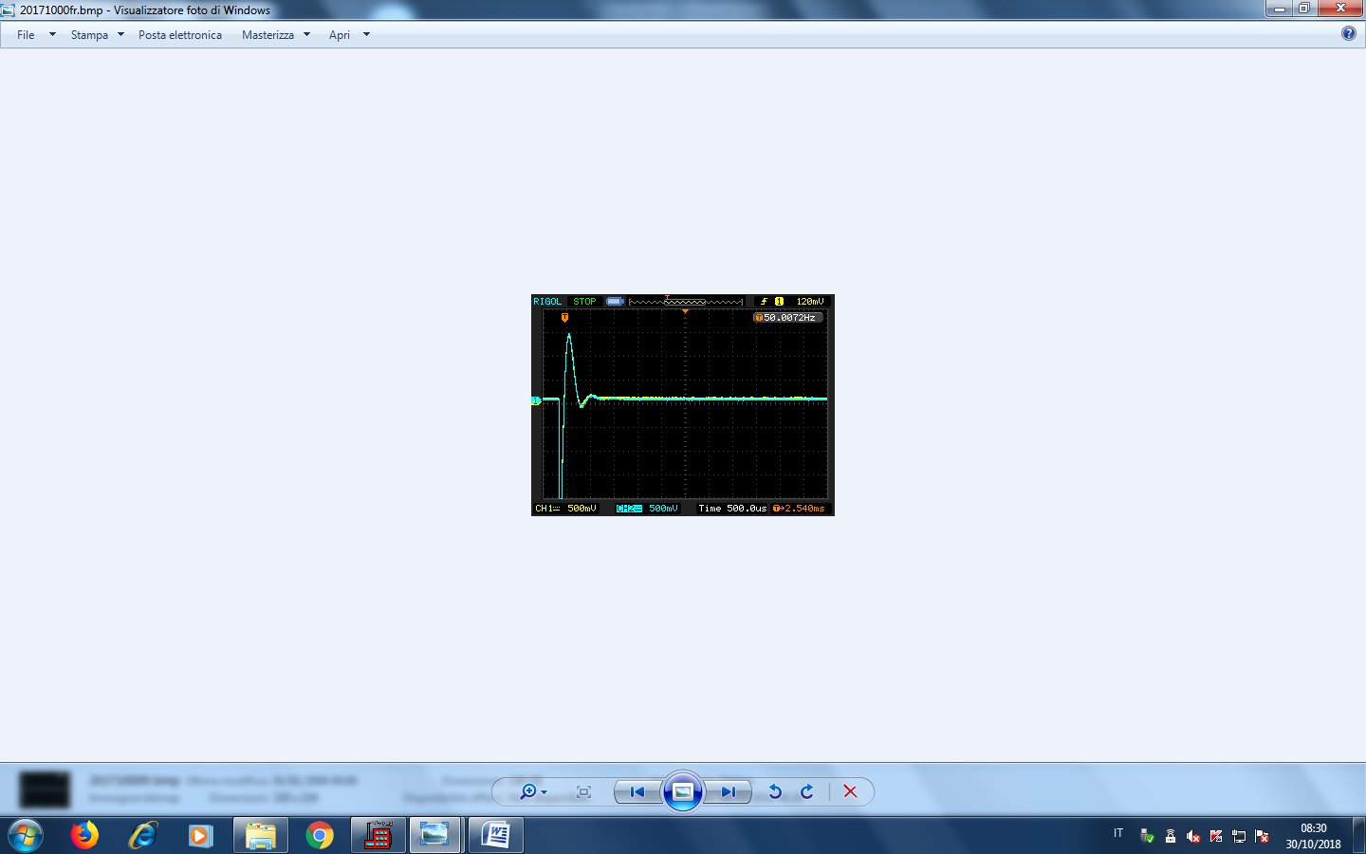**SURGE TEST BOBINA FRENO**

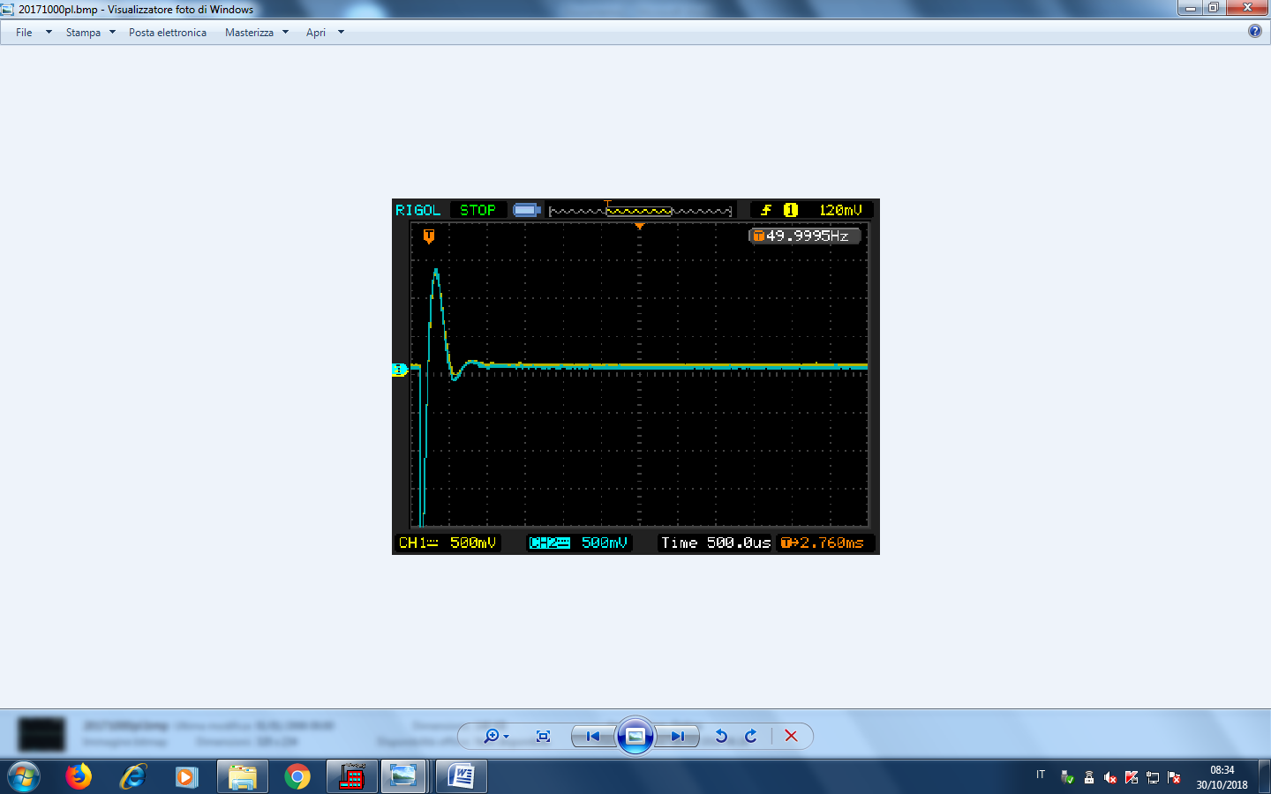**SURGE TEST BOBINE VOLANO**