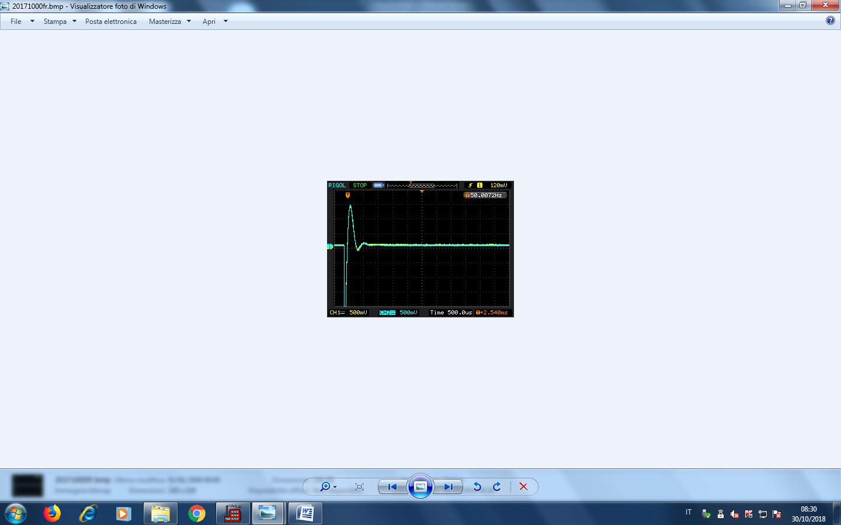

**SURGE TEST BOBINA FRENO**

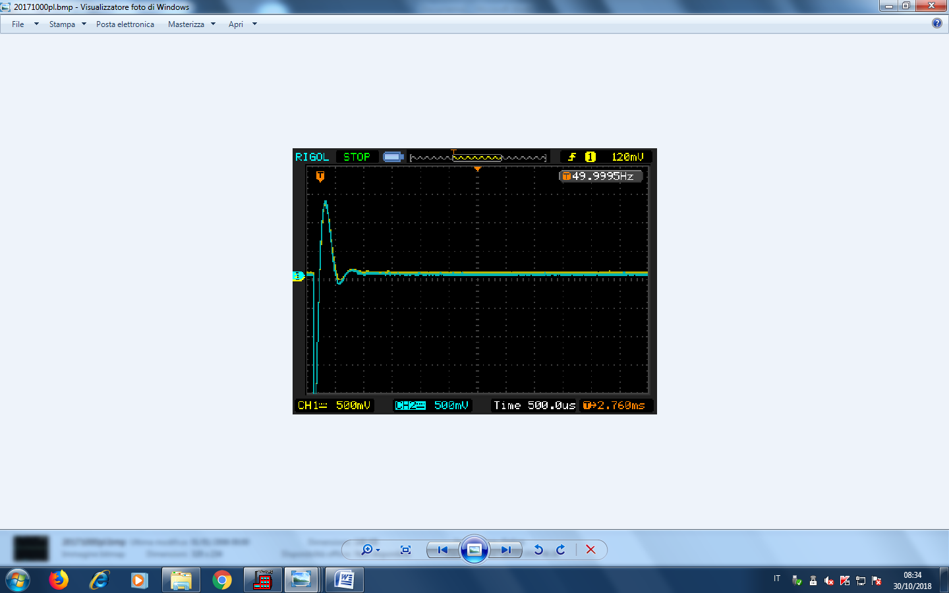

**SURGE TEST BOBINE PULEGGIA**