R.E.M.,
It was born from the passion of more decades in electromechanical and automation sector. It is currently directed by managers and technicians with a solid professional background and solid reliability. It has extensive technical facilities managed by professional workers with ability to respond appropriately to the management problems of the external environment. The R.E.M. It is able to respond, so responsive, and with new solutions, the demands coming from the most diverse sectors: automotive, pulp and paper, chemical and pharmaceutical, food industry, aerospace, military, petrochemical, and as the heart of your work is also ours, we adopted the concept of "predictive maintenance" trying to solve the problem before it occurs.
R.E.M. It is able to provide a report on the status of the machines in order to allow the scheduling of the maintenance interventions, reducing costs and downtime of the plants through the adoption of non-destructive tests, capable of determining the insulation state of electric cars. Making energy autid in industry and efficiency solutions for energy savings. The tried and tested staff and always continuously updated, working in collaboration with international partners, allows the R.E.M. to design and implement systems and automated equipment "turnkey", as well as offering advanced technological solutions of existing plants and machinery. Is followed every single step in the smallest details, from installation, start-up, an efficient after sales service, which supports the customer with technical support, remote maintenance and spare parts. To keep up with the continuous technological evolutions REM, combining technical expertise in the learning experience also offers to interested companies, consulting, design and delivery of training programs with high technological content targeted to the professional growth of maintenance, PLC programmers , drives and service in general.

I Nostri PARTNERS:
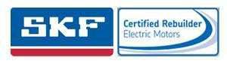






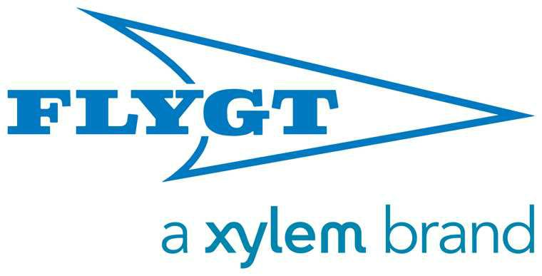

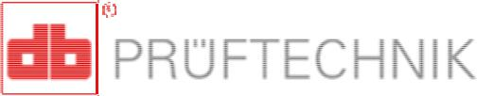
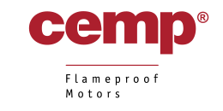
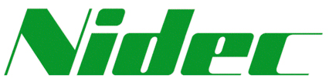


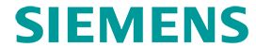

REM SRL is also:
- Authorised workshop and service center Fimet
for the center-south and islands and Fimet Agency for Lazio;
- 1st company in Italy and the eightieth in the world to be certified SKF;
- Workshop recommended Siemens; authorized workshop Electro Adda and three-phase motors EXD
- Workshop recommended Control Techniques;
- Partner Pruftechnik;
- Support SEIPEE MOTORS Center
- Authorized Service Center Faggiolati PUMPS
- Help Center Central and Southern Italian Motors LTD FELM

TEL+39.0775 830116

Fax +39.0775 839345

Website:http://www.rem-motori.it
amministrazione@rem-motori.it
ufficiotecnico@rem-motori.it
produzione@rem-.motori.it

