Configurazione ETH Magazzino 8 Cassino – F8

IP address | 10.74.31.210
Gateway | 10.74.16.1
Subnet Mask | 255.255.240.0

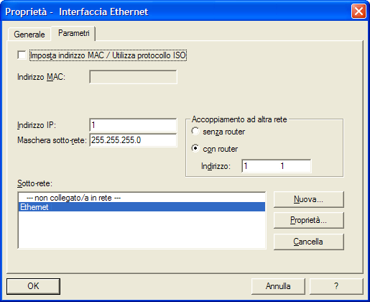
10.74.31.210
255.255.240.0
10.74.16.1

