SOFIR CONSORTILE S.R.L.
SEDE DI MILANO: Via Oroboni, 29 - 20161- Milano - MI
Tel.+39-02-66201985 Fax+39-02-6469206 e-mail:hq.milano@sofir.it
FILIALE DI TORINO:Strada per Torino, 49 - 10043 Orbassano - TO
Tel.+39-011-9040053 Fax+39-011-9037904 e-mail:branch.torino@sofir.it
FILIALE DI NAPOLI:Via N.Circonvallazione, 66 - 80035 Nola - NA
Tel+39-081-5124966 Fax+39-081-5120622 e-mail:branch.napoli@sofir.it
SOFIR do BRASIL: Rua Dois, 470/B CEP 32.250-010 Contagem-MG (BRASIL)
Tel.+55-31-33963182 Fax +55-31-33963491 e-mail:sofirdobrasil@sofir.it

WEB Site http://www.sofir.it
PRESSES – DIE CHANGE SYSTEM – COIL FEEDER LINE – TRANSFER – AUTOMATION – TOOLINGS
REFURBISHMENT – ENHANCEMENT - INSTALLATION - –SERVICE A.M. – SPARE PARTS

OPERATOR MANUAL
TYPE
SINGLE EFFECT
MODEL
S4-900-180-96
NUMBER
2011/1033
MACHINE
MECHANICAL PRESS MECCANICA
Rev. 1
of 30.08.12
S4-900-180-96

Reason of the manual
The present manual represents a guide for the operator in the utilisation of the machine: it contains a description of the cycles of work and a description of the interface with the system of control and supervision.

General description
The machine object of the present manual is a pressing Innse for the deformation of plate with 900 tons. The machine is checked by a PLC SIEMENS S7; the function of supervision and of interface operator is acquitted from an operator panel SIEMENS type MP377

Work cycles
The machine previews the following setted working cycles by means of the selector place on the control console:

- Intermittent cycle
- Excluded cycle
- Single cycle
- Automatic cycle (optional)
- Mould changhe cycle (optional)

Intermittent cycle (of adjustment)

Making this selection the movement of the machine operator is possible only with bi-manual order by light cloth. The admitted movement speed is reduced compared to the maxim and it corresponds to a cadence of 4 blows / minute, the pressing is not therefore possible to full ability.
In this condition the next operations are admitted:

- inversion of the sense of march of the pressing
- manual regulation of the sledge

Single cycle

This selection foresees the arrest of the pressing to the P. M. S. to each cycle. The movement of the pressing is ordered by the push-button panels to bi-manual order connected with the corresponding connectors to the base of the uprights of the pressing. The buttons of the bi-manual orders must have pressed at the same time and maintained up to the overcoming of the P. M. I. , exceeded which the pressing returns automatically to the P. M. S. also with given buttons.

In the case more than one push-button panel is connected, the movement of the pressing will happen only using the activated push-button panel. In this modality of job the speed of presses is correspondent to the maximum cadence of 16 blows/min; in such case the stamping to full ability is possible. In case the command of execution of a single working cycle was given with the sled not to P.M.S., for example for a precedence command interrupted from the release of one of the commands bi-manuals, presses it could not be able to acquire a sufficient speed to execute the stamping. In this case, it will be necessary to select the intermittent cycle, to invert the movement sense and to carry the sled to the P.M.S., therefore to select of new the single cycle and to proceed with the working.
Safety of the operators is guaranteed by uses it of the manual command and from the fact that the dangerous zone is watched by barriers searchlights that, in case of participation they arrest the movement immediately. All the operations of possible manual regulation and movement in the intermittent cycle are inhibited.

Operating interface
The supervisor's function is satisfied by the interface man - machine and SIEMENS realised by means of light cloth operator with monitor to colours and functional keys type MP277 10 \" key.

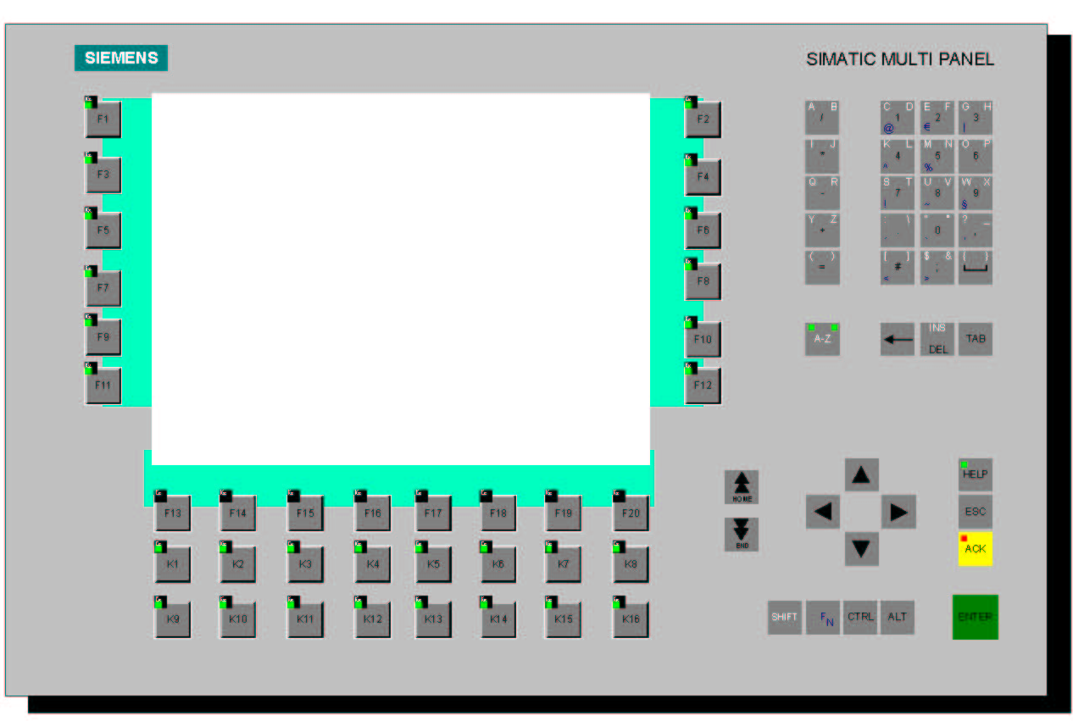

Through this interface, the operator is able to interact with the system of control of the machine activating of the orders, setting up parameters and verifying the state of functioning. The selection of the orders happens for means of the functional keys that activate the functions corresponding as visualised on the monitor. Some pages allow to the operator to set up some operative data and to carry out the regulations necessary to the ordinary utilisation of the machine to realise the workings that are peculiar to her, other let visualise the signallings of alarm and the indications that guide the operator in the execution of different cycles I work, allowing the memorisation in archives of the historian of the alarms.

Description of the supervisor's pages

Choice page
To the ignition of the machine, they are guided automatically the system of control ( PLC) and the supervisor.

At the end of the initialization phase on the monitor of the supervisor the operator will be of front the screened next one: it is the choice page, I cross which the operator can choose to sail in other pages of the supervisor. In the superior part there are visualised data that will be identical for all the pages and are the next ones:

- Date and time of the operator panel.
- Angle press.
- Visualisation of the text of the last two active alarms.
- Number of the registration number in processing .
- Description of the register in processing

Work page [1]

In figure there is represented the videata of the first page of work.

In the page there is visualised the information that the operator can consult when it considers it opportune. Function it is tied to each key a compartment of text and an order that is activated when corresponding function was pressing the key.
The shown information is following them:

- Positions Angular: it visualizes the position of the sled, visualized in degrees.
- Selection cycle: it visualises the cycle selected by the driver of the pressing.
- Current speed: it visualizes the speed of presses, visualized in Blows to the minute.
- Ampere Absorbed current: it visualises the current absorbed by the principal motor, visualised in Ampere.
- Time of braking of the pressing and used degrees.
- Pressure air balance.
- Total limit of set up overload.
- Slide light: it visualises the distance between base and slides with pressing to the small and medium-sized enterprises. Share visualised in millimetres.
- Inviolable total: it visualises the number of blows that the pressing has made, visualised in unity.

Work page [2]

In figure there is represented the videata of the second page of work.

In the page there is visualised the information that the operator can consult when it considers it opportune. Function it is tied to each key a compartment of text and an order that is activated when corresponding function was pressing the key.
The visualised information is the next ones:

- Torc-Pac unit oil level.
- Torc-Pac unit oil temperature.
- Gears and disks clutch oil lubrication pressure.
- Bushes and planetariums clutch oil lubrication pressure.
- Clutch temperature.
- Bilance air pressure.
- Clear-flow unit oil level.
- Clear-flow unit oil temperature.
- Clear-flow lubrication oil pressure.

Cams [1]

The page allows us to visualise and to set up the data of the cams in production phase.

There are disposable 9 usable exits as digital electronic cams: each exit can be programmed, with reference to the angular position of the machine, setting up the phase of activation (Opening shot), that one of deactivation (Stop), time of (ms) delay, type of cam (Position / time). Each one of the exits can complete an alone cycle of activation / deactivation for each work cycle.

In the page they are visualized of the columns that they identify:

- Number of the single cam.
- State: visualization, through LED green, of the state of every cam. If active or it disables.
- Description: description of the use that has been made or that it is wanted to be made of the single cam.
- Start: programmable angle of START of the cam according to the movement of the sled.
- Stop: programmable angle of STOP of the cam according to the movement of the sled.
- MS : time of delay of the cam to time
- Type cam: type of cam (position with corner of beginning and corner of purpose) (Time with corner of beginning and time of activation)

It is possible as well on this page to do the test of the working for every single cam.
It is necessary nevertheless to position the selector presses to intermittence.

Archive Page Rolls

The page allows us to visualise and to set up the number of prescription letting to the operator load it into machine.

In the supervisor containing the setting of the work and configuration pages data necessary for a certain kind of manufacturing, with a certain die different recipes (rolls) are storable, in disk file. The prescriptions are organised for number of matricula: in the retinue the term will be used indifferentemente it receives or matricula to indicate a particular data set. In all the pages visualised by the supervisor, there is brought back the indication on which, the number of matricula of the prescription, it has been loaded into machine and is “in working”. The supervisor allows to editare a prescription while another is found in working: in such case the number of freshman in EDIT, whose values are visualized in the pages, will be different from that brought back for the freshman in working. To select and to print a present matricula in archives to use the buttons “Preceding Matricula” and “Following Matricula”, or inserting the number of the matricula directly into the box “Matricula to be loaded / cancelled / printed / created”. To create a new matricula, to load in machine or to cancel an existing matricula, before selecting the order through key function, it is necessary to write the number of the matricula wanted in the special field and to press the key I send to confirm the datum.

The keys function relative to the matriculas qualified in this page, are the next ones:

- Loaded freshman: Charge the set of data (prescription or freshman) in the supervisor in order to afford the visualization or the modification.
- It saves matricula: Disk saves the set of data (prescription or matricula) in the unity
- You transfer a license number to PLC: PLC transfers the set of data (a recipe or a license number) showed thereof and puts it on death penalty. This operation is possible alone with the selector machinery positioned on ntermittenz to this water single.
- It cancels matricula: It cancels the set of data (prescription or matricula) selected in the special field
- It copies from matricula to matricula: It saves the data set up by a matricula to other one. The matriculas must be selected in the special fields

5.5.1 The page recipe skids

The page allows us to show and set up the manufacturing of the sledge for every single recipe data.

5.5.2 Page recipes cams

The page allows us to show and set up the given some camme of every single recipe.

There are disposable 9 usable exits as digital electronic cams: each exit can be programmed, with reference to the angular position of the machine, setting up the phase of activation (Opening shot), that one of deactivation (Stop), time of (ms) delay, type of cam (Position / time). Each one of the exits can complete an alone cycle of activation / deactivation for each work cycle. There are disposable two visualisation pages, with nova exits each one.

In the page they are visualized of the columns that they identify:

- Number of the single cam.
- Description: description of the use that has been made or that it is wanted to be made of the single cam.
- Start: START programmable corner some cam in function of the movement of the sledge.
- Stop: programmable angle of STOP of the cam according to the movement of the sled.
- MS: delay time of the cam to time.
- Type cam: type of cam (position with angle of beginning and angle of end) (Time with angle of beginning and time of activation).

Visualization's page is given, machine

The page allows us to visualize the data of plate of presses.

Page regulation Sled

The page allows us to visualize the state of the regulation of the sled.

This page allows to the operator to regulate the share of the sledge in such way that the die climbed the machine works correctly and without be damaging.
The regulation can be done only in intermittence, pressing the keys function GONE UP and GONE DOWN the operator moves manually the position of the drift and / or premilamiera leading the regulation position to the desired value.

During the operation there can be verified on the monitor the state of the qualification of the order, of the brake and of the stop. In the moment in which there is exceeded the limit of position set up for the stop SW , the movement of the regulation is arrested and allowed only that one in the opposite direction. To avoid rising up of inconveniences due to the mechanical sliding or to a breakdown of the sensor of position, two are present stop HW.
In order to avoid damages to the mechanics, in the case in which one of the stop HW turns out to be activated, the active movement of the regulation sledge is inhibited and allowed the alone opposite movement.

In the page the next information is visualised:

- Present value: visualisation of the real share of the regulation of the sledge.
- Preset change stamps: visualization of the quota regulation in exchange stamps.
- Preset value in job: visualization of the quota regulation in job.
- Been a stop superior HW : visualisation of the state of the stop, in slope.
- Been a stop inferior HW : visualisation of the state stop, in descent.
- State qualification: visualization of the qualification of the regulation axis.
- Excitation brake: visualization of the command of motor sfrenatura regulation.

Page control hydraulic safety Sled

The page allows us to visualize the data of hydraulic safeties of the sled.

In this page it is possible to visualise the values limit of the effort over which the alarm intervenes: in this case the pressing is arrested instantly and the relative alarm signalling is activated. There are visualised the maximum values of the efforts recorded during the last cycle of working and the instant values. The detachable values are extracted from the pressure measures in the hydraulic cushions put into correspondence of four connecting rods that move the sledge and are expressed in tons. In the centre of the protection there is brought back the value of the total effort exercised by the machine, in the last cycle, also this espresso in tons. The preset values have been saved in a file on disk in the management of the matriculas.

To restore the overload it is necessary to turn the selector “OVERLOADED RESTORATION” I post on the pulpit and there will start flashing the spy of signalling “OVERLOADED RESTORATION”, only when this operation has been carried out it will be possible to enliven the pressing. At this point to lead the pressing to the PMS , to wait that the spy of signalling “OVERLOAD OK ” catches fire, and to press the button “Reset anomalies”.
After having carried these operations out, the pressing will be again ready for the work.

Alarms page

The page allows us to visualize the state of the alarms.

In this page there are visualised all the signallings and the active alarms. The operator must verify the motives that have caused the present signallings to video, and after having removed the causes it can proceed when alarms were pressing the button of reset.

Alarm historyc

The page allows us to visualise the historical state of the alarms filed on disk.

In this page the chronology of the alarms is visualized that have been manifested from the moment of ignition of the car.

PLC Diagnostic

The page allows us to visualise the state of the net PLC and all the equipment.

In this page there is visualised the synoptic one of the architecture of the system of control ( PLC), bringing back the state of functioning of different forms. The present numbers on each form, indicate the number of active knot and his state.

Safety module diagnostic

The page allows us to visualise the state of the forms safety of the PLC.

In this page there is visualised the simplified synoptic one of the used forms of certainty, where for each one of them the state of functioning is indicated.

Press Securities

The page allows us to verify the been of the securities of the press.

By means of this page the operator is able to verify the state of the blocks of certainty that allow or hamper the access for the area of the die or on the crossbar of the pressing.

To block / unblock the sledge it is necessary that the pressing is firm, that the principal motor and the micro - inch are firm and that the selector presses it is positioned on intermittent.
After having verified all these conditions, it is possible to insert the certainty props under the die. and the relative signalling on the light cloth they will stop operator of flashing and will become fixed.
To restore the pressing, to position again the certainty props in the rest position, and to press the button of “RESET ANOMALIES” I post on the pulpit it is in command.

To enter the crossbar it is necessary to have the firm machine and to have turned the key of the “SELECTOR ENTRY TRANSVERSE” I post on the order pulpit to “0“. At this point there stops the principal motor or micro - inch (according to which it is used at present) and the bright button will start flashing “REQUESTED OPENING I CANCEL CROSSBAR” I post on the pulpit. Pressing it the gate will open only when the principal motors are completely firm.
To restore the gate, it will be enough to close it, to put to “1“ the “SELECTOR ENTRY CROSSBAR” and to restore with the button “RESET FRIGHTENS” I post on the pulpit.

Stroke counter

The page allows us to verify the stroke counter of the pressing.

In this page the production of the pressing is visualised is partial which total.
The metres “total stroke counter” and “partial stroke counter” can be set at zero through the relative buttons put on the light cloth operator.
The inviolable stroke counter cannot be reset and visualises the blows life of the pressing.
.

Dynamic brake

The page allows us to insert the data of the dynamic braking.

Into this page there are inserted the data of the dynamic braking and there are visualised the data of the used degrees, used time and corner I start braking.

The dynamic braking lets to the pressing stop within the cam of the PMS without going beyond it.
To do this it is necessary to disconnect the clutch and to slow down with anticipation degrees and to let to the pressing be stopped, with the generated mechanical inertia, within the PMS . It is raised more speeds of the pressing and first it will be necessary to order the arrest of the pressing.

To understand the inertia used by the machine to be stopped completely after the beginning of the braking, it is necessary to visualise the data of the present braking, like the used time and the degrees presses clerks.

Speed machine

The page allows us to verify the data of the blows presses.

In this page the statements of the blows are visualised it presses in all the configurations.

The speed of the machine is fixed as far as it regards the intermittence and the change prints that corrsisponde to 4 retail blows.
While the speeds set up automatically and in individual, they can vary through this page with 6 to 16 retail blows.

MICROINCH motor

The page allows us to visualize the data of operation of the MicroInch motor.

In the page the next information is visualised:

- Micro Inch enabled
- Flywell enabled
- Pinion engaged/disengaged
- Micro Inch motor status

The pinion is commanded directly by the PLC when one commands the engine

To guide the motor micro - inch it is necessary that the pressing is selected in manner intermittence, that the principal motor is completely firm, and that the pumps are alight all. At this point to press the button “MARCH MICRO-INCH ” I post on the pulpit.
It is besides possible to guide the motor micro - inch with the reverse rotation carrying out of the simple operations: To arrest the motor pressing the button “ARREST MICRO-INCH ” I post on the pulpit and to wait that is completely firm; to Turn the selector “MICRO-INCH BACK” and to guide again the motor.

Page balancer cylinder

The page allows us to visualise the state of the cylinders of balance of the sledge.

In this page there are visualised the data set up by matricula that allow to calculate the necessary pressure value for the correct balance of the weight of the sledge and of the die to her hooked.
It is necessary to set up the weight of the die in the prescription, the system will calculate automatically the value of the pressure of balance.

In this page is visualized the following information:

- Present value: visualisation of the real pressure of the cylinders equalizers.
- Preset value in work with die: visualisation of the pressure of balance of the drift and of the premilamiera , visualised in Bar.
- Preset value in work with die: I print visualisation of the weight bilanciabile , visualised in kilogramm.
- Manual/Automatic Regulation: visualization of the state of formulation of the regulation balance.
- Valve Increases/Diminishes pressure: visualization it are been of the regulation valves balance pressure.

The keys function qualified in this page, are the next ones:
- The pressure of the cylinders increases / reduces equalizers of the drift in manual cycle.
- The pressure of the cylinders increases / reduces equalizers of the premilamiera in manual cycle.

The manual regulation of the balance is possible in any case positioning the selector “BALANCE SLIDES” in manual and to act on the keys INCREASES / REDUCES balance it posts on the light cloth operator.

