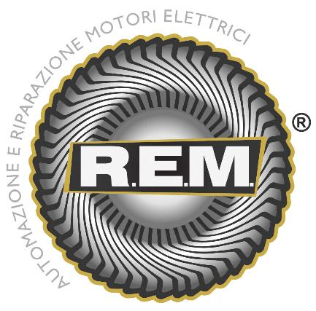
R.E.M. s.r.l.

Via Ferruccia, 16/a –

03010 Patrica (FR)

Tel. 0775830116 – Fax 0775839345
